Aug-Nov 2024 Z-Wave RF Range Testing

# Executive Summary

ZRAD easily achieves 2 miles of reliable, secure, encryption and error-free communication in direct Line-of-Sight conditions. Real world test in Urban, suburban and rural environments are documented in this report. Videos and presentations on the results were presented at Silicon Labs Works With conference as well as other events.

A test of 3 different ground planes on a Thunderboard (BRD2603) yielded nearly the same RF range. Thus a new variant of ZRAD with a much smaller ground plane and that fits in a standard enclosure has been initiated.

# Goals

* ZRAD to ZRAD ZWLR RF range testing in various environments generating a Heat Map using Geographic Location Command Class and a GPS receiver
* ZRAD End Device Mounted on a Motorcycle to move around quickly
  + Some data may be captured using an eBike or walking especially in urban environments
* ZRAD Controller running Z-Wave JS to pull GPS locations and store in a .CSV file
* What effect does the ground plane size have on RF range?
  + Can a thunderboard have significantly more range if placed on a metal plate?
    - How big of a plate? What shape?
    - Trials:
      * Four 6+” copper rods at 45 degrees below TBZ
      * Four 3” copper rods as above
      * Pie Plate non-contacting below above
      * Take each of these to North beach and measure LoS
  + Same applies to ZRAD
  + Can a smaller ZRAD sitting on a 6.5” radius plate achieve the same RF performance (or better) as ZRAD (thus a smaller and cheaper PCB)
  + Does a larger plate improve it even more?
  + Are 4 rods at 45 degree angle even better?
* What is the best RF performance at a reasonable cost?
  + The ZRAD is too big to be practical for a commercial product
  + Is it better to ship a metal plate or 4 rods? Can the customer easily add a plate if they need a little more range?
* Environments:
  + Wooded
    - [Bound](https://www.google.com/maps/place/BoundTree%2FLine+Hill+Parking/@43.2080352,-71.7716687,280) Tree ATV Henniker NH
    - Rockingham [trail](https://www.nhstateparks.org/find-parks-trails/recreational-rail-trails/rockingham-recreational-rail-trail,-fremont-branch) Freemont to Sandown
    - [Hopkington-Everet OHRV](https://www.google.com/maps/place/Hopkinton-Everett+OHRV+Trails+Area/@43.1239432,-71.6538497,1887) trails
  + Open agricultural field
    - Wagon Hill Durham NH (not quite big enough?)
  + Green houses?
  + Residential
    - Newton MA
    - Dover NH
  + Urban
    - Boston Silabs Office
      * Do the windows have metal tinting with poor RF?
      * Can we get on the roof? Probably not
      * Use the top floor of the NECCO parking deck?
      * Street parking Dorchester Ave above the bass river outside the Gillette visitor parking lot: [42.345363, -71.057275](https://www.google.com/maps/place/42%C2%B020'43.3%22N+71%C2%B003'26.2%22W/@42.3451982,-71.0575464,84m/data=!3m1!1e3!4m4!3m3!8m2!3d42.345363!4d-71.057275!5m1!1e3?entry=ttu)
        + Just over 1km down the bass river and several parking lots
    - Dover NH
      * Controller on top of the [Garrison Hill tower](https://www.google.com/maps/place/Garrison+Hill+Tower,+Abbey+Sawyer+Memorial+Hwy,+Dover,+NH+03820/@43.2094265,-70.8704013,333) which has line-of-sight to much of Dover below for several miles and plenty of urban streets
        + Too many trees – do not use
        + Can drive & park at the base of the tower
        + Trial on 8/10 did not go well. Too many trees surrounding the tower results in few if any pings even on the road just below the tower. Only time it connects is line-of-sight which is rare at ground level.
      * [Shaw Fields](https://www.google.com/maps/@43.1664761,-70.8689548,396m/data=!3m1!1e3!5m1!1e3?entry=ttu#:~:text=43.165965%2C%20%2D70.869717) is an open area surrounded by neighborhoods somewhat hilly but did yield good results
    - Strafford NH
      * The [Stratham Hill Tower](https://www.google.com/maps/place/Stratham+Hill+Tower/@43.0312354,-70.8911063,3178) is an alternative but doesn’t have as many streets nearby
      * Requires a hike up the hill to get to the tower
    - Salisbury Beach – 5 miles not quite LoS
      * [42.823773, -70.813928](https://www.google.com/maps/place/42%C2%B049'25.3%22N+70%C2%B048'50.0%22W/@42.8236998,-70.8187629,797)
      * Parking lot close to the beach then follow Atlantic Ave for a mostly line-of-sight range. Not perfect but could give as much as 5 mile range.
      * Parking lot is behind dunes with no real LoS down the beach or street
    - **North Beach** – 1.6mi LoS along Ocean Blvd
      * [42.920850, -70.798394](https://www.google.com/maps/place/42%C2%B055'15.1%22N+70%C2%B047'54.2%22W/@42.920851,-70.7990377,199)
      * Free? Parking at south end of the beach then a clear LoS along the beach with a sidewalk with a 4-5 foot concrete wall so both ends have to be elevated to ~6 feet.
      * Possibly extend to 2.7mi to North Hampton State beach with a gap due to the peninsula at Ancient Hgwy
    - Philbricks Beach/ Rye beach – 1.4mi but no parking
    - York Beach – 1.6mi LoS then Nubble Lighthouse neighborhood
      * [43.147698, -70.626328](https://www.google.com/maps/place/43%C2%B008'51.7%22N+70%C2%B037'34.8%22W/@43.147699,-70.6269717,198)
    - Plum Island beach – no parking near the beach, too sandy
  + Water – need a boat – lakes or the ocean depending on the weather
* At some point:
* Use ZRAD to capture GPS, but also capture stats of other devices
  + Use Indicator Get? ZWInfo Get? Needs to be a secure GET to know frame made both directions clean
  + ZW mesh with ZRAD
  + Commercial products
    - Ring
    - Zooz light switch? Blink xmas lights all over the bike and night Electric Cowboy style!
      * Need a large battery and inverter – Jackery?
    - 3Labs flow meter
* Compare with Wifi, Zigbee, Matter, Lora, others?
  + 2.4 protocols in urban environments will probably suck due to all the noise
* Compare with YAGI antenna – point-to-point
* Example use-cases
  + Track skydiving jump (Homeseer)
  + Track model rocket launch
  + Track glacier movement for months at a time (need low-power)

# Journal

## 2023-11-11 Compare TBZ RF Range with 3 different ground planes

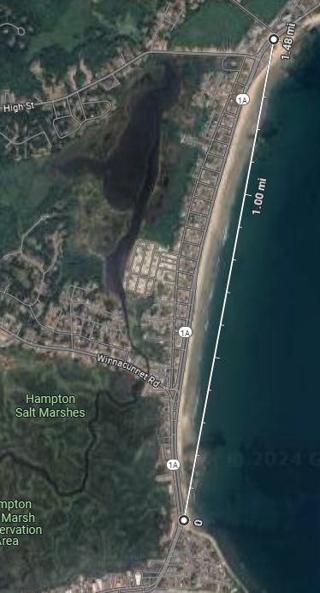Added 12” copper rods to the SMA of a TBZ ZGM230 board. Compared this with ZRAD at [North Beach](https://www.google.com/maps/@42.9214228,-70.7979883,118m/data=!3m1!1e3?entry=ttu&g_ep=EgoyMDI0MTEwNi4wIKXMDSoASAFQAw%3D%3D#:~:text=42.921133%2C%20%2D70.798465) in Hampton NH. ZRAD is the controller and mounted to a pole at ~6’ above the ground. ZRAD and the TBZ use the same GPS module but each data set is a separate run. The ED is mounted to the handlebars of an eBike which is then ridden on the sidewalk adjacent to the beach for a LoS range of about 1.5mi. Since the ZGM230 is limited to 14dBm this should be more than enough distance. There is a 5’ seawall along the beach so the ED must be mounted somewhat high on the handlebars.

Trials:

1. ZRAD->ZRAD
2. ZRAD->TBZ with 12” copper rods
3. ZRAD->TBZ with 6” copper rods
4. ZRAD->TBZ no extra grounds

TBZ has QWIIC pins on different pins than ZRAD: SCL=PB05, SDA=PB06. I copied the SwOnOff_7222_ZG23B_geoCC_ZRAD project to *TBZ and changed the pinout and target MCU. Copying the TBZ project didn’t work. Had the wrong part (still an SoC) which didn’t have the right pins at all. I had to start over and reinstall GeoCC from a fresh SwOnOff_7222_TBZ_GeoCC. Had difficulty getting the base project to build under 7.22.2 – getting a –no-warn-rwx-segments error. I disabled a couple of other warnings. Removed the option by following [this](https://community.silabs.com/s/question/0D5Vm000000kGczKAE/matterextension-version-220-compiles-with-a-nowarnrwxsegment-error?language=en_US).

Flash is overflowing by 9k! Fortunately changing the -O option to -Os from -Og got it to fit! And it works! The changes to ZW_classcmd.h are built into the 7.22.2 SDK on my computer which makes it easier to install.

TBZ Board 147 DSK: 23063-31288-04510-25690-52479-49105-31800-52055

Joined to the ZRAD as Node 263

Works well in the neighborhood.

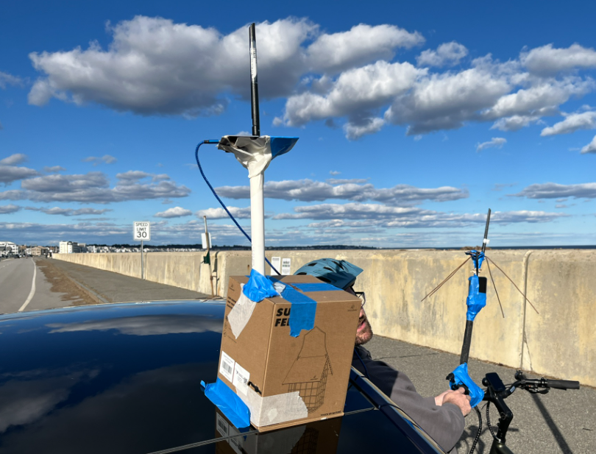Testing at North Beach: ZRAD controller is mounted 2’ above the roof of a Tesla. Both the DUT and controller have the [TI.92.2113](https://www.mouser.com/ProductDetail/Taoglas/TI922113?qs=P1JMDcb91o7ty6jAS%2Fx1TA%3D%3D&utm_id=9491304176&gad_source=1&gclid=Cj0KCQiAlsy5BhDeARIsABRc6ZspFnZusxF15gNFVY4oCkL2RfIcO-ki0ndwO17XWrewT-ufLhKA7i4aAs2mEALw_wcB) antenna which was found to be excellent in previous testing. Temperature was mid-60F, sunny and breezy.

**Summary**: Four tests were conducted to compare ZRAD with a Silabs Developers Kit BRD2603A also known as the Thunderboard Z-Wave (TBZ). The net result is that a large ground plane did not make a measurable difference in the overall RF range. Thus, a ZRAD-mini will be developed to make a smaller more cost-effective reference design.

**Location:** North Beach isn’t quite long enough line-of-sight to fully test ZRAD at 1.5 miles. There is a short stretch of direct LoS for 400 meters before the road curves and the 5’ seawall sometimes blocks direct LoS (but Z-Wave is able to go over this wall). Further out the road rises and the seawall is low enough to be direct LoS. Data is checked in to ZRAD/test/RangeTesting/202411TBZ.xlsx. Excels 3D maps feature is used to draw these graphs. The other files from today are also checked into this folder.

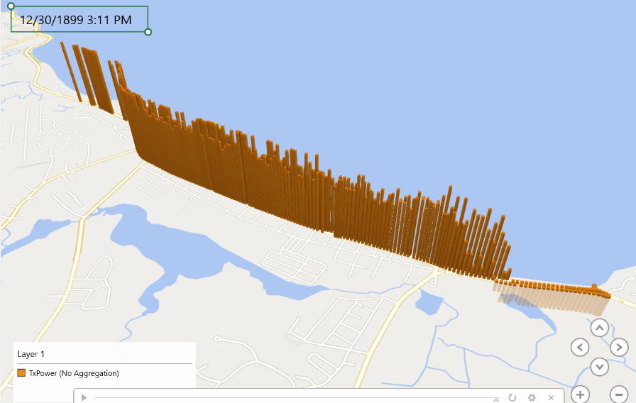**ZRAD->ZRAD** – Max Range = 3.12km (1.94mi). Average TxPower=7.91, Average RSSI=-82.36. TxPower=-6 for the entire LoS of 400m. Max range is limited by the terrain as there are houses beyond 1.5mi.

TxPower is the vertical height.

**ZRAD->TBZ with 12” ground rods** – Max Range=2.97km (1.85mi). Average TxPower=11.12, Average RSSI=-84.97. TxPower is -6 for the 400m LoS on the return trip but on the way out it has a few data points that are 10 and 13 probably caused by the bike riders body blocking LoS since the DUT is mounted on the handlebars. Even though the TBZ uses the ZGM230 which has a max TX power of 14, with large ground rods it gets nearly the same RF range in this location. However, the max range is mostly limited by the terrain as there are houses in the way beyond 1.5mi.

**ZRAD->TBZ with 6” copper ground rods** – Max Range=2.97km (1.85mi). Average TxPower=9.77, Average RSSI=-85.97. TxPower is -6 for the LoS on the return trip but not on the way out. In general, TxPower is close to 20 for most of the outbound trip and the max range is 2.6km (1.61mi) before the houses get in the way. The average power is lower but if the -6 values are excluded it is slightly higher than the 12” rods.

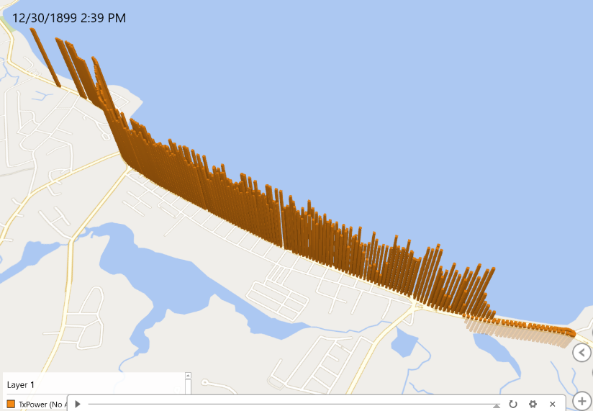**ZRAD->TBZ with 0” ground rods** – Max Range=3.14km (1.95mi), Average TxPower=11.87, Average RSSI=-91.68). The ground rods apparently make no significant difference! The TBZ has slightly more range than ZRAD but again the problem is that this location is not long enough to give a direct LoS at the max range. So even a slight change in orientation or a few feet change in X and Y provide a clearer path thru the houses than ZRAD. The TBZ has a max TxPower of +14dBm which should result in about ½ degradation in RF range compared to ZRAD but at this location and with this test setup it was basically the same. A future test should use sub-optimal antennas especially on the controller end (perhaps use a USB stick). Suboptimal antennas should limit the range to within the LoS at this location but will only be valid for comparisons relative to other devices.

## 2024-11-08 Debug getting zeros from M8Q

It appears the ZG23 and the GPS module get out of sync sometimes probably resulting in the checksum failing and then GeoLoc reporting zeros for the values. But the GPS is locked, it’s a comms problem. Setup the M8Q with ZRADs which are dumping the NMEA sentences out the uart to see if I can identify the problem. The checksum looks OK but the firmware is reporting zero Sats – that’s a bug!

The M8Q (and any ublox module) outputs 0xFF when the buffer is not ready yet which is different than the XA1110 which used 0x0A.

Data from the M8Q:

$GLGSV,2,2,06,85,20,255,15,86,22,312,25,1*7Ex0D$GLGSV,2,1,05,68,00,104,,70,52,328,,71,11,299,,73,06,186,,0*74x0D$GLGSV,2,2,05,73,06,186,,0*41x0D$GAGSV,3,1,09,04,34,278,28,10,41,271,25,11,30,304,27,12,39,238,31,7*78x0D$GAGSV,3,2,09,19,73,021,29,21,30,120,23,27,25,060,25,29,33,075,21,7*74x0D$GAGSV,3,3,09,33,10,188,22,7*4Ax0D$GAGSV,1,1,01,06,10,271,,0*46x0D$GBGSV,2,1,06,21,77,061,,22,27,108,,26,38,182,,42,42,306,,0*7Bx0D$GBGSV,2,2,06,42,42,306,,43,09,279,,0*76x0D$GQGSV,1,1,00,0*64x0D$GNGLL,4310.24308,N,07052.27943,W,150303.00,A,D*64x0D$GNRMC,150304.00,A,4310.24307,N,07052.27944,W,0.024,,081124,,,D,V*00x0D$GNVTG,,T,,M,0.024,N,0.044,K,D*3Ex0D$GNGGA,150304.00,4310.24307,N,07052.27944,W,2,12,0.56,51.2,M,-32.5,M,,*47

!GNGGA,150304.00,4310.24307,N,07052.27944,W,2,12,0.56,51.2,M,-32.5,M,,Sats=0 3,21,44,23,25,12,10,32,28,24,,,,1.18,0.56,1.04,1*05x0D$GNGSA,A,3,79,86,80,78,69,,,,,,,,1.18,0.56,1.04,2*04x0D$GNGSA,A,3,27,11,12,19,29,21,10,33,04,,,,1.18,0.56,1.04,3*0Ex0D$GNGSA,A,3,26,42,22,21,45,,,,,,,,1.18,0.56,1.04,4*0Ax0D$GNGSA,A,3,,,,,,,,,,,,,1.18,0.56,1.04,5*0Bx0D$GPGSV,3,1,10,10,83,266,44,12,31,093,30,15,00,095,11,21,19,310,12,1*65x0D$GPGSV,3,2,10,23,48,145,31,24,30,052,26,25,27,140,28,28,29,222,39,1*69x0D

It seems the problem is the 2 in the Q field (fix type) which is typically 1 when “locked” but in the M8Q it’s sometimes 2 (DGPS). Changed the code to check for non-zero. Seems to work much better.

## 2024-10-31 Skydiving with M8Q

DSK: 48236-63088-30059-28345-51573-04769-34612-42030

PS100 with the new M8Q GPS receiver and a ZRAD controller using the Yagi antenna. The PS100 only has a simple PCB antenna and is tucked inside a fanny-pack so there is some loss there.

It’s taken 4 tries to finally get good data but ZRAD did it! It was determined there was a bug in the firmware that resulted in a few gaps in the data but there is more than enough to show the range of over 2.7 miles.

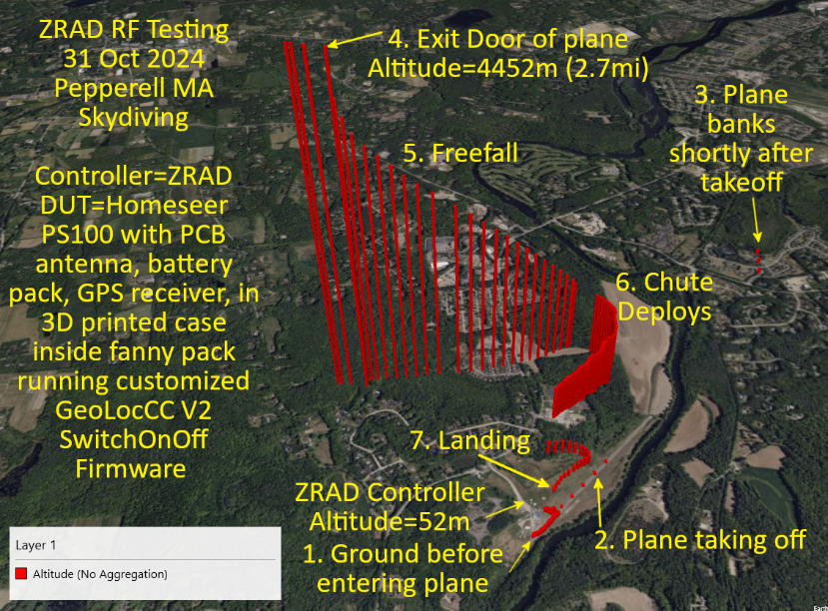Net result is ZRAD easily achieved more than 2.7miles of obviously clear LoS since it’s nearly straight up. The actual distance is a little more than 2.7 miles since the downrange distance would have to calculate the exact angle.

1. Data begins with Jonluke walking toward the airplane and finally entering it
2. Data points spread out as the plane accelerates down the runway. RF connection is lost from inside the metal airplane even though Jonluke is sitting close to the large door.
3. A few more data points are captured when the plane is banking after takeoff
4. Secure connection is re-established when Jonluke is at or just outside the door of the plan but still holding on as the altitude remains the same at 4452 meters (2.7 miles). Note that Z-Wave had to negotiate the connection, exchange Nonces and then finally begin returning GPS coordinates all at the extreme edge of RF range. The TXPower is at +20dBm during this period.
5. The GPS coordinates record the rapid drop and movement of freefall
6. The chute deploys and the data points get closer together. Data is captured every three seconds. The gap in the data at this point was determined to be a bug in the GeoLocCC code which mis-interpreted certain conditions. This bug has since been fixed.
7. Jonluke lands safely as it told the data is GOOD!

The surprising part is that the PS100 has a PCB antenna which is likely the limiting factor. The ZRAD controller had the Yagi antenna which has a gain of 3dBm which helps make up for the loss of the PCB antenna. Plus, the PS100 is inside a 3D printed enclosure and is then inside a fanny pack.

ZRAD is mostly unable to reach the DUT when inside the metal airplane even though Jonluke was right in front of the door. There are a few points where it connected going down the runway and at the first bank of the plane. The plane may also have some RF noise in the 900MHz band limiting the connection.

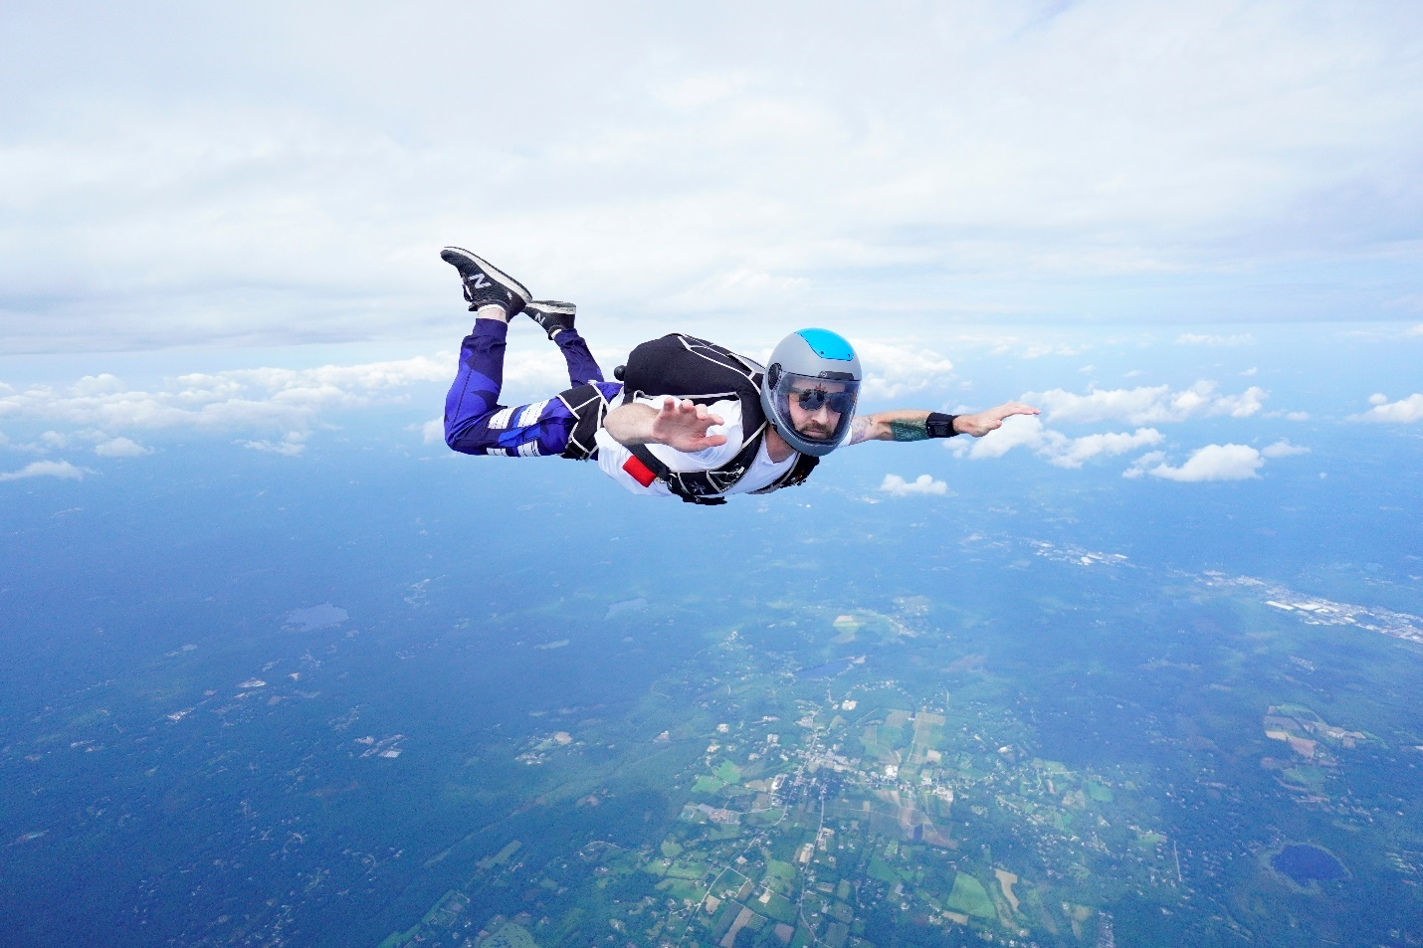



## 2024-10-30 M8Q

Soldered a QWIIC connector to a new PS100 which will allow me to try different GPS modules with the PS100. But that does make it mechanically less robust as now there are qwiic connectors that could come loose.

M8Q appears to work much better. First of all, the M8Q is harder to shield and seems to lock onto the satellites better (barely get it to lose lock with the 3 anti-static bags whereas the XA needed only 2). When first powered up indoors the altitude was inaccurate – saying 10m instead of 35. Once outside but in the car, it did adjust in ~10s and seemed to give accurate readings. When I bagged the module, it said it still had 9 satellites but the alt started going negative. As soon as I started driving the M8Q lost lock and reported zeros. I drove to 150’ of altitude and unbagged it which it locked on in a few seconds but still with the negative 100m but slewed back to the correct value fairly quickly.

## 2024-10-28 Skydiving with M8Q

Soldered the M8Q to a PS100 in preparation to jump at Pepperell. We have the XA unit as a backup. Either way we will keep the unit out on the way up to try to keep GPS locked as much as possible. The M8Q is easier to solder as the 3.3V and GND are in the correct order (XA had to reverse 3.3/GND) but there is a spare pin between them making it easy to solder and more reliable. SDA/SCL are reversed but that’s easy to fix in software. First try I end up getting -3 from the I2CSPM driver which is ArbLost. I suspect I need pullups? Nope just had one of the pins wrong.

I plugged the PS100 into my new battery but it will produce 20V for high-speed charging which the old PS100 incorrectly will default to and then fries the chip. Unfortunately, it also fried the GPS module. I have more coming in tomorrow.

## 2024-20-24 ZOE-M8Q GPS debug

Using the ZRAD to debug the ZOE-M8Q GPS module (which is more expensive) to see if it is accurate. The I2C address is 0x42. First problem is that my ZRAD builds no longer work since adding 2024.6.2 so it appears I have to build a new project – UGH. I will add the necessary files to the SDK version of ZW_classcmd.h so I don’t have to keep rebuilding it for each project. There are several GPS modules from Sparkfun – the XA appears to be the oldest, the SAM-M10Q is the newest (highest product number) but is $175.

## 2024-10-22 XA1110 Debug

Does the XA1110 have a bug when it loses GPS lock, you move a long way, then it reacquires GPS lock but “predicts” the location based on the location when it lost lock before? Or is this a feature and it assumes you’re roughly in the same location? Our use case is pretty unique – jumping from a plane!

I have the [ZOE-M8Q](https://www.sparkfun.com/products/15193) GPS module so we can try that as well but it might take some debugging to get it to work.

On Powerup the XA1110 produces:

GNGGA,155510.685,,,,,0,0,,,M,,M,,Sats=0

!GNGGA,155511.686,,,,,0,0,,,M,,M,,Sats=0

!GNGGA,155512.686,,,,,0,0,,,M,,M,,Sats=0

!GNGGA,155513.686,,,,,0,0,,,M,,M,,Sats=0

!GNGGA,155514.686,,,,,0,0,,,M,,M,,Sats=0

!GNGGA,155515.675,,,,,0,0,,,M,,M,,Sats=0

!GNGGA,155516.677,,,,,0,0,,,M,,M,,Sats=0

!GNGGA,155517.677,,,,,0,0,,,M,,M,,Sats=0

!GNGGA,155518.678,,,,,0,0,,,M,,M,,Sats=0

!GNGGA,155519.682,4310.222976,N,07052.276710,W,1,4,1.87,13.699,M,-32.898,M,,Sats=4

!GNGGA,155521.000,4310.224534,N,07052.275692,W,1,4,1.87,16.979,M,-32.898,M,,Sats=4

!GNGGA,155522.000,4310.226014,N,07052.275366,W,1,4,1.87,19.049,M,-32.898,M,,Sats=4

!GNGGA,155523.000,4310.226959,N,07052.275089,W,1,4,1.87,19.348,M,-32.898,M,,Sats=4

!GNGGA,155524.000,4310.227364,N,07052.275021,W,1,4,1.87,19.776,M,-32.898,M,,Sats=4

!GNGGA,155525.000,4310.227673,N,07052.275005,W,1,4,1.87,20.619,M,-32.898,M,,Sats=4

!GNGGA,155526.000,4310.228133,N,07052.275035,W,1,4,1.87,21.524,M,-32.898,M,,Sats=4

!GNGGA,155527.000,4310.228467,N,07052.274708,W,1,4,1.87,23.313,M,-32.898,M,,Sats=4

!GNGGA,155528.000,4310.228969,N,07052.274406,W,1,4,1.87,24.911,M,-32.898,M,,Sats=4

!GNGGA,155529.000,4310.229147,N,07052.274493,W,1,4,1.87,24.935,M,-32.898,M,,Sats=4

!GNGGA,155530.000,4310.228520,N,07052.274529,W,1,4,1.87,24.305,M,-32.898,M,,Sats=4

!GNGGA,155531.000,4310.227924,N,07052.274402,W,1,4,1.87,23.572,M,-32.898,M,,Sats=4

!GNGGA,155532.000,4310.227245,N,07052.274275,W,1,4,1.87,22.730,M,-32.898,M,,Sats=4

!GNGGA,155533.000,4310.227013,N,07052.274096,W,1,4,1.87,21.553,M,-32.898,M,,Sats=4

!GNGGA,155534.000,4310.226763,N,07052.274049,W,1,4,1.87,18.961,M,-32.898,M,,Sats=4

!GNGGA,155535.000,4310.226401,N,07052.274219,W,1,4,1.87,17.068,M,-32.898,M,,Sats=4

!GNGGA,155536.000,4310.226108,N,07052.274389,W,1,4,1.87,15.520,M,-32.898,M,,Sats=4

!GNGGA,155537.000,4310.225683,N,07052.274419,W,1,4,1.87,14.423,M,-32.898,M,,Sats=4

!GNGGA,155538.000,4310.226284,N,07052.274583,W,1,4,1.87,14.089,M,-32.898,M,,Sats=4

!GNGGA,155539.000,4310.226812,N,07052.274703,W,1,4,1.87,14.056,M,-32.898,M,,Sats=4

!GNGGA,155540.000,4310.231549,N,07052.275739,W,1,5,1.62,8.519,M,-32.898,M,,Sats=5

!GNGGA,155610.000,4310.244083,N,07052.278198,W,1,5,1.61,28.401,M,-32.898,M,,Sats=5

!GNGGA,155611.000,4310.244419,N,07052.278470,W,1,4,2.55,28.640,M,-32.898,M,,Sats=4

This is with the DUT stationary on my desk. Note that the Altitude is changing quickly. My phone says I am at 150’ or 45m which is where it eventually averages down to. The blue LEDs blinks but the number of Sats is zero sometimes. Putting the WSTK and the PS100/module in an anti-static bag shields the GPS even with an external antenna (inside the bag).

After more testing where I put the XA in an antistatic bag to shield it then drove around to various altitudes I conclude that the XA is a POS. The altitude is all over the map and even the location has errors. I suspect this is an attempt to hot-lock quickly instead of using the actual data from the satellites.

## 2024-09-24 Skydiving

I replaced the GPS module which has failed and tested the entire system in my neighborhood before setting out for skydiving.

We got data, but the GPS receiver seemed to lose lock while in the plane, then when JL jumped, it assumed it was still at the same height (and location?) and then went down from there which is why the altitude went to -353m? Seems like a bug in the GPS module? But we have some data and can try to adjust for the correct height. The data is all wrong, it seems to skew to the south at various points. The landing is not where JL landed. It is accurate when he entered the plane and even while it was running down the runway. Thus, the data is not valid. We’ll have to debug a bit more on what is going wrong. I’ll try capturing the NMEA sentences and move from great bay (sea level) to the top of garrison hill (300 feet) while the GPS is shielded in a bag and see if it is indeed a bug in the GPS module or is the GeoLoc code misinterpreting the code somehow? The top of pack Monadnock is 2290’ which is still less than 1000m but you can drive to the top.

## 2024-09-22 Skydiving

The PS100 with a GPS module attached DSK: 36788-38368-23483-57296-48512-20243-61028-59393. JL has 3D printed a case and purchased an always-on USB power brick. This should make the DUT robust enough to survive skydiving in JLs fanny pack. Unfortunately for some reason once the board was installed in the case it no longer talks to the GPS module. The GPS blue light is on but GeoLocCC is always 0. Is there a broken wire between the module and the PS100?

The problem is that the SCL signal is stuck at 2.8V. SCL is connected to PIN 2 (PC01) which is the RX pin of the schematic and pin 4 of the header. Nope – using the scope downstairs the SCL is working fine but the XA is not ACKing. The address is 001000. This XA1110 is dead – it doesn’t ACK even after connecting to a 2nd PS100. I put another XA onto the original board and now it is working. I did find that L2 was missing on the original board. Not sure how that was broken off but it was – likely during my desoldering/resoldering the XA on. I ordered 2 more XA1110s as I don’t have any more.

## 2024-08-26 – Waltham and Boston

Waltham:

In the morning Eric and Mark captured GPS data from inside his home at 16 Caughey St in Waltham MA using ZRAD at both ends. An eBike was used to travel around the neighborhood in a roughly spiraling fashion. The raw data is in the file 202408Waltham.csv. Use excel to import the data and display a heatmap. Screenshot then paste into GIMP to annotate and measure the distance using google maps.

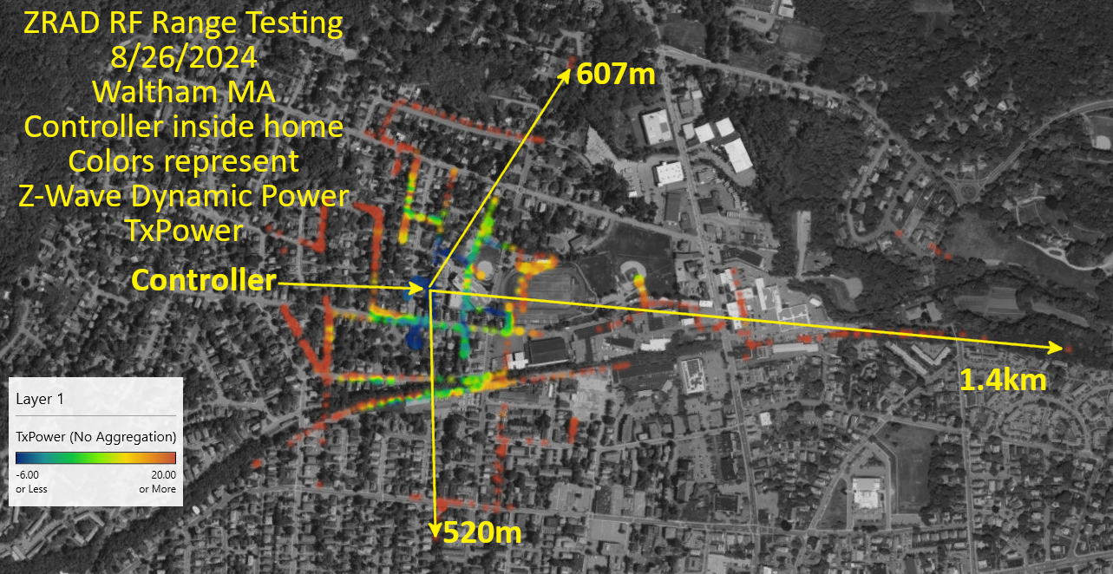

Conclusion: Z-Wave reliably achieves 300m in most any direction from inside a typical wood frame home in a dense suburban environment. There are holes in certain places where Z-Wave cannot reach. Note that the path from the controller to the word “controller” has only a few data points indicating this is a blocked area. Probably due to a chimney in the house or the home directly behind the controller. The controller is in a room facing east which is why that direction is the furthest. The home is also on a hill which is why the west direction is limited once you crest the top of the hill.

Boston

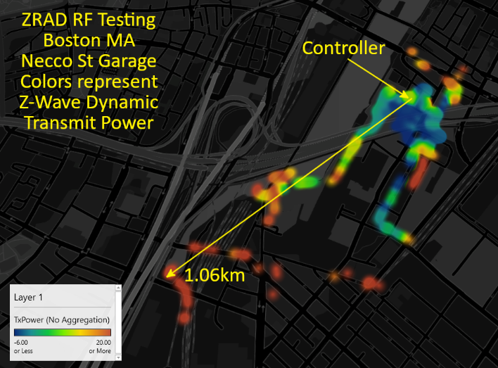The controller was located on the top of the Necco street garage as described on 8/16. ZRAD achieved over 1km of direct Line-Of-Sight RF range in a dense, noisy urban environment. Naturally there is limited penetration thru the concrete and steel buildings. However, ZRAD was able to connect thru all 6 floors of the parking garage and thru/around some of the concrete buildings. Note that not every street was attempted and we were not able to enter various parking lots and side streets.

## 2024-08-25 – Skydiving

Spent the day at the Pepperell Jump center in Pepperell MA with the PS100 with a GPS attached and custom firmware. During the first jump the unit shifted in JonLukes fannypack such that the GPS receiver antenna was against the power brick. While we were able to connect via Z-Wave for a few times in the plane on the way up (only a couple), and connected reliably once the chute was open, the GPS was unable to lock on to the satellites and unfortunately returned 0. For the second jump the DUT stopped talking as soon as JL entered the plane. Once he was down and we unpacked the DUT, the USB connector had ripped off so it was unpowered the entire trip. So we will have to try again next month. JL with 3D print an enclosure and include a power brick that does not have a power button and will not shut off due to the light load of the PS100.

We shot all the video we need. Just need to capture some real data. JL created this [Google Drive](https://drive.google.com/drive/folders/1vU3nZDT6jln5AGIAbmIvg7ir2KrEbAll) to store the video/data.

## 2024-08-24 – PS100 with GPS

Trying one more time. I deleted a couple of SDKs and cleanly installed SSDK202461. Then tried to install the EUSART IO Stream and then Debug Print. That worked and SSv5 let me configure the EUSART IOs. The RED LED works with a basic on/off. Not sure why the blue (or green) LED doesn’t work with an Indicator CC but that’s not important.

Installing GeoLocCC:

* Follow the GeographicLocation CC Readme.md file step-by-step instructions
  + The ZW_classcmd.h file has moved to: C:\Users\eric\Documents\GitHub\SwOnOff_ZG23A_444_PS100\simplicity_sdk_2024.6.1\protocol\z-wave\dist\include\zwave
* Need to copy the I2CSPM instructions into the GeoLoc readme – follow these to install I2C
  + SCL=PC01
  + SDA=PC00

It works!

## 2024-08-23 – GPS with a PS100

I cannot get the WSTK to connect to the ZG23. It draws about 43mA. The CPU is running OK as the LEDs flash when booting. The GPS module is able to lock into satellites. But SSv5 and commander will not connect which I need to update the firmware to support GeoLocCC. The same WSTK and SSv5 software will connect to a regular PS100 so there must be something wrong with this board.

RESET occasionally goes high and low but is at 1.8V for much of the time? Reset goes high and low and sometimes is only at 1.8v but seems normal. The problem is just that the chip was locked. I unlocked it and now I can program it. SSv5 didn’t simply tell me the chip was locked, simply said it couldn’t connect. Ugh.

Next challenge is getting the firmware to work.



DSK=06733-04021-36719-63457-43790-15174-07656-35296

commander flash --token MFG_ZWAVE_COUNTRY_FREQ:0x09 -s 440263534 --device EFR32ZG23 --tokengroup znet

Once the FREQ was set properly then it joined the network immediately. Indicator CC doesn’t do anything but Basic ON/Off turns on the Red LED. Need to get indicator CC to work as that’s what the GPS script uses. LED2 is supposed to be indicator CC. Well no idea why Indicator CC doesn’t work but not really needed. Let’s see if I can get the GPS wired up.

Installed Z-Wave Debug Print which now properly also installs the USART dependency. Uncommented DEBUGPRINT in app.c. Unfortunately that caused an error in SSv5 which then trashed the project so I have to start over again. This time I tried to enable the EUSART and debug print first. Doesn’t compile – tried to add various items to configure the Ios.

## 2024-08-21 – Connecting GPS to a PS100

The Homeseer PS100 is planned to be used in a skydiving video. To accomplish this, a XA1110 GPS module needs to be wired to the PS100. The question is to use the I2C interface, or the UART interface of the XA1110. I haven’t used the UART interface yet but it would be a lot easier to parse. But I’d have to rewrite some code to get it to work. And the UART pins are on the wrong set of pins (other side of the module). Thus, stick with the I2 interface. The PS100 GPIOs can be anything so I’ll use the MOTION pin. Naturally power and ground are reversed from what is needed. The PS100 does not have a QWIIC connector so it must be hardwired to the pins of the radar module which is not needed for range testing.

|  |  |  |  |
| --- | --- | --- | --- |
| **Signal** | **PS100** | **XA1110** | **Comments** |
| 3.3V | 5 | 3 | Naturally it’s reverse of what is needed |
| GND | 4 | 4 |  |
| SDA | 3 | 2 |  |
| SCL | 2 | 1 |  |

Wired up the board with just a header but it is soldered so it should be reliable. Does it need a GPS antenna? Can always connect one to the UFL. Not sure it’ll fit in the case but I can make it fit well enough. Will do the software tomorrow.

Quick calculation of the power needed to keep a USB power brick alive. They don’t spec the current but the PS100 with the radar module usually stays awake which is about 100mA. A 33 ohm resistor will pull 100mA at 3.3V and dissipate 1/3 watt so need a decent size resistor to handle that. Can a 100 ohm resistor (33mA) keep it awake?

## 2024-08-16 – BoundTree ATV trails in NH

Completed shooting the video out at a dairy farm in Henniker NH and at the BoundTree Trails in Henniker NH: [43.207900, -71.771031](https://www.google.com/maps/@43.2076885,-71.7710248,140m/data=!3m1!1e3!5m1!1e3?entry=ttu)

No data was captured at the dairy farm as we couldn’t travel around the fields. The corn was 7’ tall so getting thru it would limit the range. Would need to mount the controller up high on a barn roof for the range to be good.

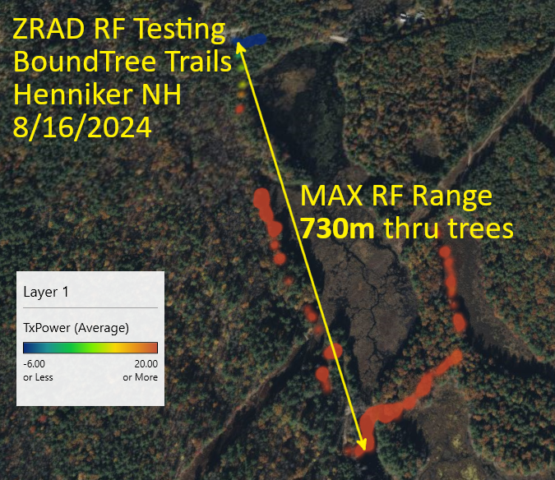Data has captured at Bound Tree but again the focus was on the video with limited real data captured. The .csv file is 20280817BoundTree.csv. The problem with this location is that the forest is dense so range is limited. RF Range is 730m thru a lot of trees but at full power and was marginal much of the time. Wanted to have Mark spiral out across many of the trails but ran out of time.

## 2024-08-16 – Downtown Boston

While shooting the Works With video, the hope was to capture data in the city environment near the Silabs office. The Necco street garage has a decent view down the harbor but there are many concrete and steel tall buildings in the area which will limit RF range.

We were there early in the morning shooting the video on the empty top floor. However, security came up and said we cannot shoot video and made us leave before we could capture any significant amount of data. The file is 20240815Boston.csv.

The date/time isn’t incrementing in the .csv file. Moved the capture of the Date to within the While loop.

## 2024-08-12 – Shaw Fields Dover NH

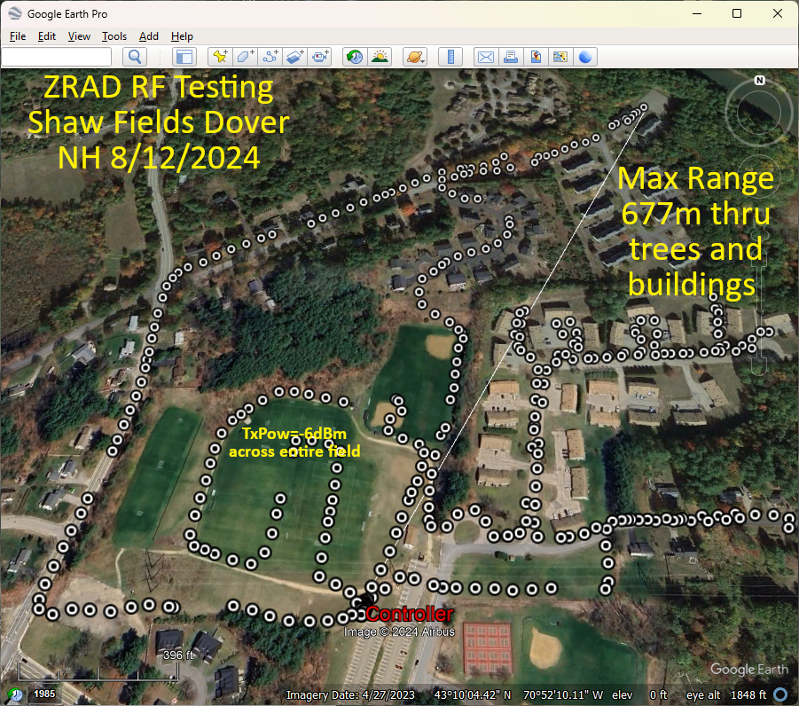The Shaw fields in Dover are open fields surrounded with neighborhood streets. The area is hilly but the fields are flat with the parking lot on a hill overlooking them. There is only about 300m of direct line of sight. Time didn’t allow capturing the entire area and I was walking but an eBike with a faster sample rate would be a better idea to get more data faster.

The fields yielded -6dBm TxPower levels at over 150m. The longest range is 677m but that includes numerous trees and wood frame condos in between. TxPower is +20 at that extreme.

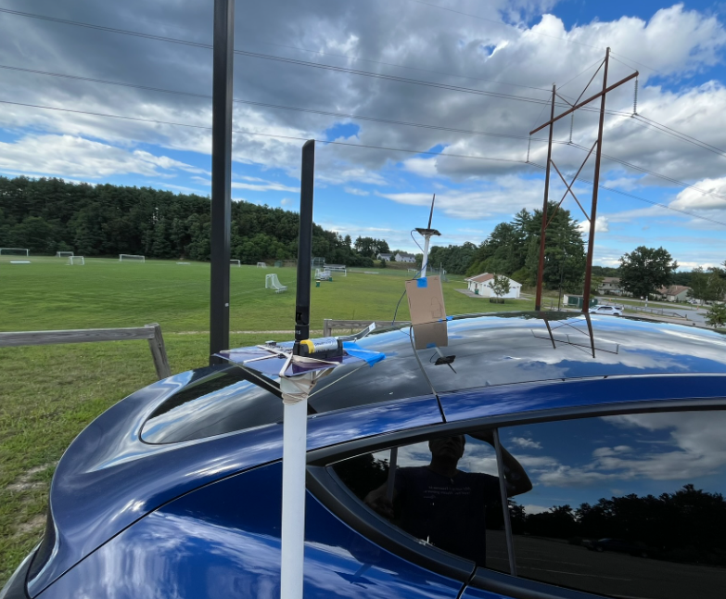The controller is mounted about 24” above a Tesla on a PVC pipe. Is the roof of the car providing additional ground plane effect to increase range? Will have to experiment with the controller standalone well away from any metal. If that is much shorter, then we’ll have to try with a cookie sheet or circular cardboard wrapped in aluminum foil! Maybe 4 or 8 rods at a 45 degree angle?

Google Earth Pro (download the desktop version) creates the image above via:

1. Edit the .csv to have only the data to be plotted
2. Open GEPro
3. File->Open
4. Select Generic Text (*.csv)
5. Pop-up will open to select the columns
6. Latitude and Longitude are usually detected automatically from the 1st row of the .csv
   1. If not, select them
7. Change the format from STRING to FLOATING POINT (this is the key)
8. Click on Finish
9. View-> check Sidebar
10. Scroll down to the imported file, click the check on and the points will be displayed
11. Use Add Path to add a path – the length is shown in the Length tab (change to meters)
12. In the sidebar, select the Controller data point, change its name and color
13. Screen shot then add more text to the image using Gimp

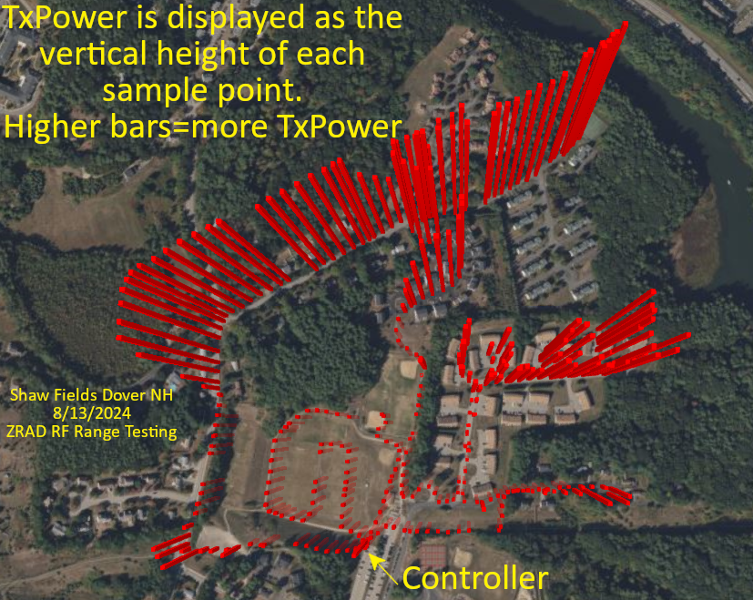This image is created using Excel 3D maps feature

1. Open the .csv in Excel
2. Save the file as .xlsx
3. Click on 3D Maps (if not in the toolbar, search for it)
4. The 3D maps app should open and automatically find the Latitude and Longitude
5. Zoom in on the location – the points are all mashed together as the dots are far too large
6. Layer Options
   1. Reduce size to 0
7. Click on Height and add TxPower – reduce the height to zero percent
8. Change the color as desired
9. Themes -> select one with a satellite view
10. Screenshot and add more text using Gimp
11. 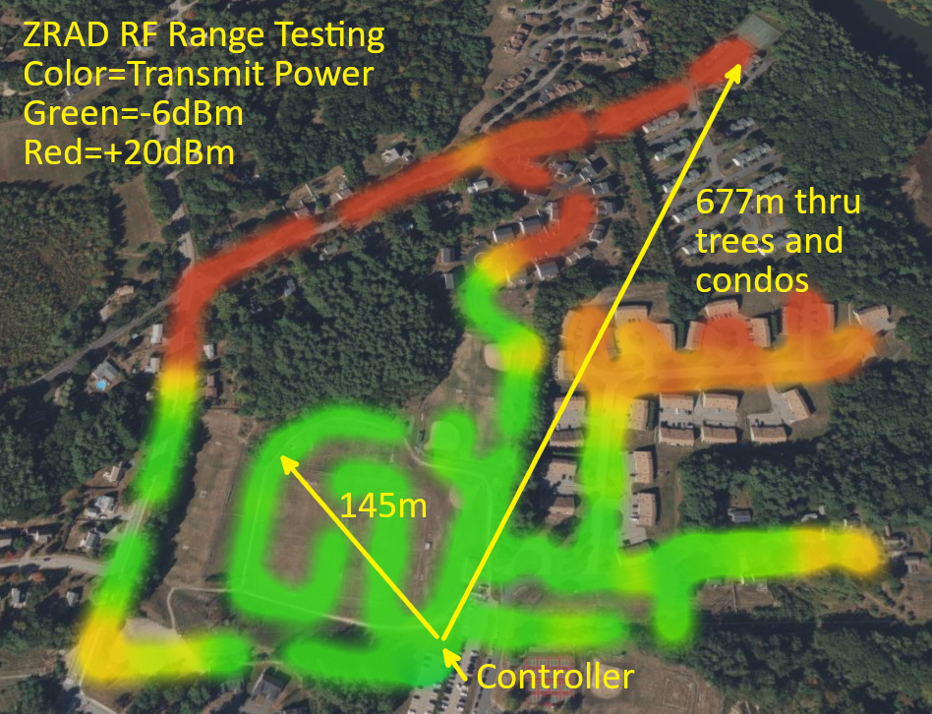To create a heatmap, click on the heatmap icon at the top of the Layer Pane
12. Change Visual Aggregation to Average
13. Adjust the radius of Influence and the color scale to the desired levels
14. Try other options
15. Screenshot and add text/arrows in Gimp

Raw data is in the file 202408ShawFields.csv checked into the ZRAD repo in the Test folder.

## 2024-08-10 – Dover Garrison Hill Tower

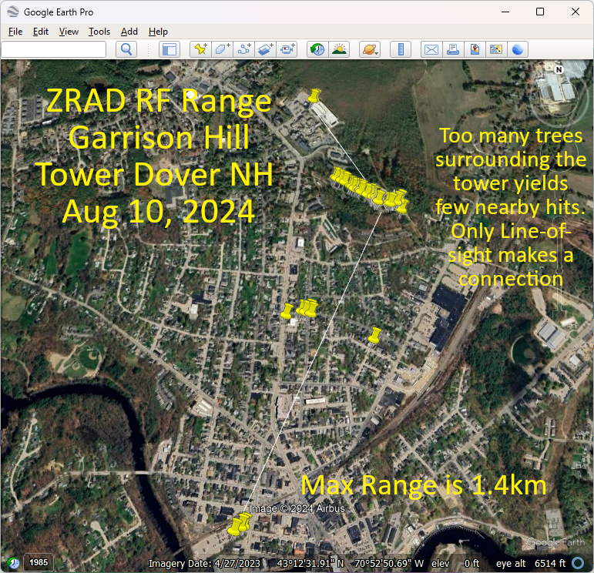Trial run at the Garrison Hill tower which has a commanding view of the city of Dover NH. The problem is the tower is surrounded with a thick forest which from the top of the tower you can just see over the tops of the trees. This means there are no connections made to the streets immediately below the tower thru all the trees. The few line-of-sight locations in the city will connect at over 1.4km but there are few of these at ground level. Lots of 3 story buildings and more trees block the LoS.

Download Google Earth Pro which can import the .csv file and display it on a map and take measurements. Note that the online version of Google Earth does NOT have the feature to import a .csv file. This does not appear to import the altitude, just 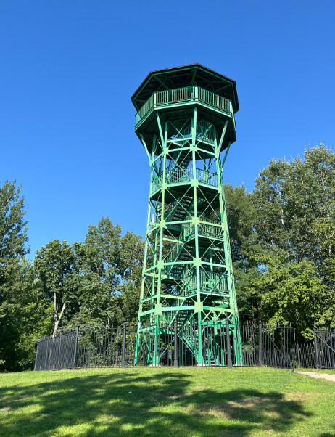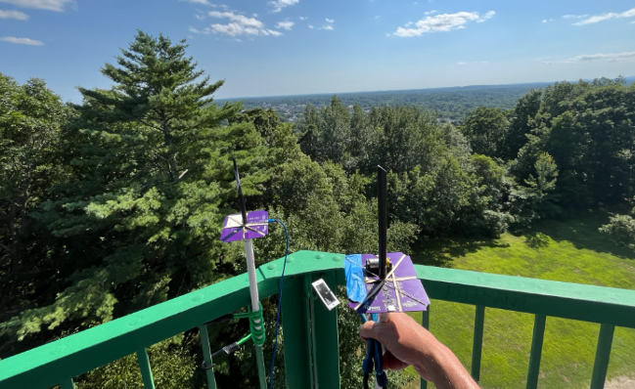Lat/Lon. Tried a few CSV to KML conversion utilities but GE still doesn’t seem to how the altitude.

Still looking for a mapping solution that will produce a 3D model for skydiving or rocketry that shows the altitude.

Raw data:

Time, Latitude, Longitude, Altitude, TxPower, RSSI, Sat Aug 10 2024 15:19:13 GMT-0400 (Eastern Daylight Time)

03:19:13 PM, 43.20914840698242, -70.8693618774414, 182.85, 0, 0

03:19:13 PM, 43.20912551879883, -70.86934661865234, 182.85, 0, 0

03:19:13 PM, 43.2091064453125, -70.86935424804688, 182.85, 0, 0

03:19:13 PM, 43.209556579589844, -70.8694076538086, 110.76, 0, 0

03:19:13 PM, 43.20950698852539, -70.86963653564453, 112.66, 0, 0

03:19:13 PM, 43.20948028564453, -70.86962127685547, 112.71, 0, 0

03:19:13 PM, 43.20952224731445, -70.86958312988281, 112.74, 0, 0

03:19:13 PM, 43.209510803222656, -70.86959075927734, 112.79, 0, 0

03:19:13 PM, 43.209510803222656, -70.86959075927734, 112.79, 0, 0

03:19:13 PM, 43.20949172973633, -70.86959075927734, 112.79, 0, 0

03:19:13 PM, 43.20949172973633, -70.86958312988281, 112.79, 0, 0

03:19:13 PM, 43.20948028564453, -70.86958312988281, 112.92, 0, 0

03:19:13 PM, 43.20948028564453, -70.86958312988281, 113.18, 0, 0

03:19:13 PM, 43.20948028564453, -70.86957550048828, 113.33, 0, 0

03:19:13 PM, 43.20948028564453, -70.86957550048828, 113.33, 0, 0

03:19:13 PM, 43.2094841003418, -70.86957550048828, 113.57, 0, 0

03:19:13 PM, 43.20949935913086, -70.86959075927734, 114.15, 0, 0

03:19:13 PM, 43.209503173828125, -70.86958312988281, 114.19, 0, 0

03:19:13 PM, 43.209495544433594, -70.86959075927734, 114.23, 0, 0

03:19:13 PM, 43.20949935913086, -70.86959075927734, 114.26, 0, 0

03:19:13 PM, 43.20949935913086, -70.86959075927734, 114.27, 0, 0

03:19:13 PM, 43.209495544433594, -70.86959838867188, 114.39, 0, 0

03:19:13 PM, 43.20949935913086, -70.86959838867188, 114.4, 0, 0

03:19:13 PM, 43.209495544433594, -70.86959838867188, 114.44, 0, 0

03:19:13 PM, 43.20949935913086, -70.86959075927734, 114.23, 0, 0

03:19:13 PM, 43.209503173828125, -70.8696060180664, 114.28, 0, 0

03:19:13 PM, 43.20951843261719, -70.86962127685547, 114.25, 0, 0

03:19:13 PM, 43.20949172973633, -70.86962890625, 114.39, 0, 0

03:19:13 PM, 43.20949172973633, -70.86962890625, 114.46, 0, 0

03:19:13 PM, 43.20948791503906, -70.86962890625, 114.72, 0, 0

03:19:13 PM, 43.20948791503906, -70.86962890625, 114.76, 0, 0

03:19:13 PM, 43.20949172973633, -70.86962890625, 114.76, 0, 0

03:19:13 PM, 43.209495544433594, -70.86962890625, 114.22, 0, 0

03:19:13 PM, 43.209495544433594, -70.86962127685547, 114.05, 0, 0

03:19:13 PM, 43.209495544433594, -70.86961364746094, 114.02, 0, 0

03:19:13 PM, 43.209495544433594, -70.8696060180664, 114.01, 0, 0

03:19:13 PM, 43.209495544433594, -70.8696060180664, 114.28, 0, 0

03:19:13 PM, 43.209495544433594, -70.8696060180664, 114.37, 0, 0

03:19:13 PM, 43.20949935913086, -70.86961364746094, 114.45, 0, 0

03:19:13 PM, 43.20950698852539, -70.86961364746094, 114.48, 0, 0

03:19:13 PM, 43.209495544433594, -70.86962890625, 113.76, 0, 0

03:19:13 PM, 43.209495544433594, -70.86963653564453, 113.7, 0, 0

03:19:13 PM, 43.20950698852539, -70.86963653564453, 113.49, 0, 0

03:19:13 PM, 43.209495544433594, -70.86964416503906, 112.86, 0, 0

03:19:13 PM, 43.209449768066406, -70.86972045898438, 113.86, 0, 0

03:19:13 PM, 43.20943069458008, -70.86981201171875, 116.74, 0, 0

03:19:13 PM, 43.20942306518555, -70.86993408203125, 118.76, 0, 0

03:19:13 PM, 43.209434509277344, -70.87007141113281, 120.62, 0, 0

03:19:13 PM, 43.20954895019531, -70.87053680419922, 118.04, 0, 0

03:19:13 PM, 43.20954895019531, -70.87054443359375, 117.98, 0, 0

03:19:13 PM, 43.20954895019531, -70.87054443359375, 118.11, 0, 0

03:19:13 PM, 43.20954513549805, -70.87055206298828, 117.93, 0, 0

03:19:13 PM, 43.20953369140625, -70.87055969238281, 117.61, 0, 0

03:19:13 PM, 43.209537506103516, -70.87055206298828, 117.55, 0, 0

03:19:13 PM, 43.20953369140625, -70.87055206298828, 117.59, 0, 0

03:19:13 PM, 43.20953369140625, -70.87055206298828, 117.62, 0, 0

03:19:13 PM, 43.20953369140625, -70.87055206298828, 117.63, 0, 0

03:19:13 PM, 43.20953369140625, -70.87055206298828, 116.77, 0, 0

03:19:13 PM, 43.209529876708984, -70.87055969238281, 116.38, 0, 0

03:19:13 PM, 43.20952606201172, -70.87056732177734, 115.39, 0, 0

03:19:13 PM, 43.20953369140625, -70.87055969238281, 115.86, 0, 0

03:19:13 PM, 43.209529876708984, -70.87055969238281, 115.28, 0, 0

03:19:13 PM, 43.209529876708984, -70.87055969238281, 115.12, 0, 0

03:19:13 PM, 43.209529876708984, -70.87055969238281, 115.1, 0, 0

03:19:13 PM, 43.209529876708984, -70.87055206298828, 115.16, 0, 0

03:19:13 PM, 43.209529876708984, -70.87055206298828, 115.16, 0, 0

03:19:13 PM, 43.209529876708984, -70.87055206298828, 114.67, 0, 0

03:19:13 PM, 43.209529876708984, -70.87055206298828, 114.61, 0, 0

03:19:13 PM, 43.209529876708984, -70.87054443359375, 114.56, 0, 0

03:19:13 PM, 43.209529876708984, -70.87054443359375, 114.37, 0, 0

03:19:13 PM, 43.20952606201172, -70.87054443359375, 112.99, 0, 0

03:19:13 PM, 43.20952606201172, -70.87054443359375, 113.14, 0, 0

03:19:13 PM, 43.209537506103516, -70.87054443359375, 113.21, 0, 0

03:19:13 PM, 43.20954513549805, -70.87054443359375, 113.26, 0, 0

03:19:13 PM, 43.20954513549805, -70.87055206298828, 113.24, 0, 0

03:19:13 PM, 43.2096061706543, -70.87062072753906, 113.13, 0, 0

03:19:13 PM, 43.209716796875, -70.870849609375, 109.28, 0, 0

03:19:13 PM, 43.209815979003906, -70.87113952636719, 102.61, 0, 0

03:19:13 PM, 43.20994186401367, -70.87145233154297, 96.4, 0, 0

03:19:13 PM, 43.204952239990234, -70.87549591064453, 39.67, 0, 0

03:19:13 PM, 43.197731018066406, -70.87783813476562, 28.76, 0, 0

03:19:13 PM, 43.19785690307617, -70.87754821777344, 29.44, 0, 0

03:19:13 PM, 43.19789505004883, -70.8774185180664, 29.73, 0, 0

03:19:13 PM, 43.204017639160156, -70.87120819091797, 38.08, 0, 0

03:19:13 PM, 43.20500564575195, -70.87425994873047, 52.11, 0, 0

03:19:13 PM, 43.20512008666992, -70.87433624267578, 52.22, 0, 0

03:19:13 PM, 43.20505905151367, -70.87454986572266, 52.2, 0, 0

03:19:13 PM, 43.20509338378906, -70.87472534179688, 51.47, 0, 0

03:19:13 PM, 43.214290618896484, -70.87380981445312, 71.92, 0, 0

03:19:13 PM, 43.21426010131836, -70.87390899658203, 72, 0, 0

03:19:13 PM, 43.214263916015625, -70.87390899658203, 71.91, 0, 0

03:19:13 PM, 43.214263916015625, -70.8739013671875, 71.94, 0, 0

03:19:13 PM, 43.2105827331543, -70.87279510498047, 80.26, 0, 0

03:19:13 PM, 43.21054458618164, -70.87272644042969, 81.1, 0, 0

03:19:13 PM, 43.21044921875, -70.87248992919922, 85.54, 0, 0

03:19:13 PM, 43.210365295410156, -70.87230682373047, 89.83, 0, 0

03:19:13 PM, 43.2101936340332, -70.87200164794922, 100.19, 0, 0

03:19:13 PM, 43.21015930175781, -70.87191772460938, 102.55, 0, 0

03:19:13 PM, 43.210086822509766, -70.87181854248047, 103.75, 0, 0

03:19:13 PM, 43.210086822509766, -70.87167358398438, 105.19, 0, 0

03:19:13 PM, 43.21006774902344, -70.87158203125, 105.62, 0, 0

03:19:13 PM, 43.210025787353516, -70.8714828491211, 106.06, 0, 0

03:19:13 PM, 43.210018157958984, -70.87147521972656, 106.04, 0, 0

03:19:13 PM, 43.20982360839844, -70.87091064453125, 103.57, 0, 0

03:19:13 PM, 43.20981216430664, -70.87089538574219, 103.56, 0, 0

03:19:13 PM, 43.209693908691406, -70.87068176269531, 104.28, 0, 0

03:19:13 PM, 43.2095947265625, -70.87054443359375, 103.38, 0, 0

03:19:13 PM, 43.2095947265625, -70.87053680419922, 103.17, 0, 0

03:19:13 PM, 43.2095947265625, -70.87052917480469, 103.28, 0, 0

03:19:13 PM, 43.209590911865234, -70.87052917480469, 103.39, 0, 0

## 2024-08-09 – Call With Sam & Mark

Sam showed the script for the marketing video. Data is totally secondary but the real data is important to Mark and I. The production team is arriving Monday! Thursday Boston, Friday is NH.

## 2024-08-08 – Initial discussions with Mark Umina

Introduced Sam Ponedal who is Silabs marketing